An alternative way of presenting these results is using column charts with error bars to represent the means and standard deviations. Figure 3.18 is an example of such a column chart for capacity of the largest stadium.

Figure 3.18. Capacity of largest stadium.

Most students are more than capable of producing pie charts, line graphs and column charts in Microsoft packages. However, there is one type of chart that students do need to ask supervisors about in the author’s experience and that is a column chart with error bars such as the one shown in Figure 3.19. Therefore, the way in which this type of chart is produced in Microsoft Excel is described here to assist students. Firstly, the student should type in the means and standard deviations they will be reporting in the chart as shown in Figure 3.20. We highlight the means and headings (cells A1 to B3 in Figure 3.20) and then use **Insert → Column** and choose the type of column chart we want (no error bars at this stage). It is best to delete the legend of the chart because both columns are the same colour and the horizontal axis shows what each column represents.

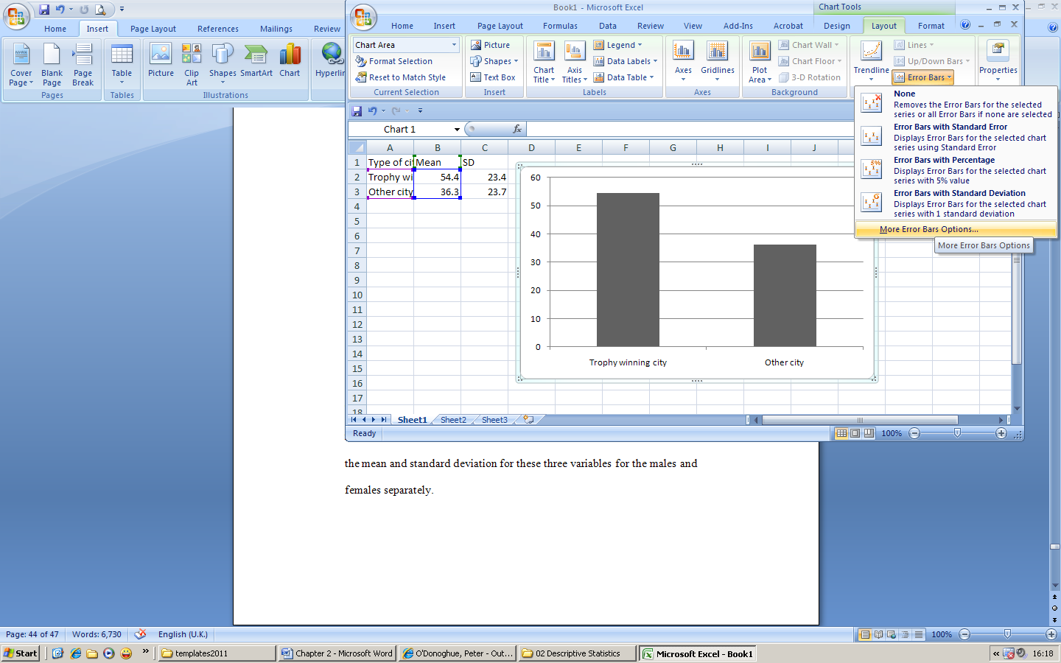

Figure 3.20. Producing a column chart in Microsoft Excel.

When we double click on the chart, the menus change to be specifically for chart editing. We choose the **Layout** tab and see an error bars option toward the right of the screen as shown in Figure 3.20. The **Error Bars** drop down menu provides a choice of options from which we choose ‘More error bar options’. This activates the popup window shown in Figure 3.21. We choose ‘Plus’ so as we only have an error bar on top of the column, ‘Cap’ so as there is a ‘T’ on top of the error bar and ‘Specify’ which means that we tell Excel what the standard deviations are.

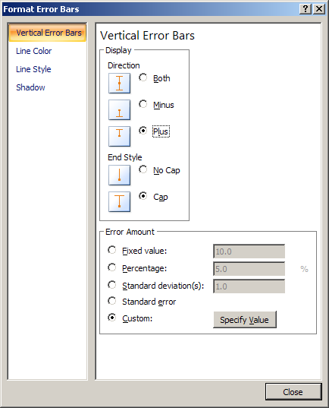

Figure 3.21. Formatting Error bars.

We then click on the **Specify Value** button which shows the Custom Error Bars popup window as shown in Figure 3.22. This allows us to select the standard deviations we placed in the cells C2 and C3. With the insertion point of the mouse in the ‘Positive error bar values’ area of the Custom Error Bars pop up window simply drag the mouse over the cells containing the standard deviations (C2 and C3) and then release. Some text appears in the ‘Positive error bar values’ area that you may not understand; it is just Microsoft Excel’s reference to the cells we have chosen on the given sheet. The negative error bar values should be given a literal ‘0’. Click on **OK** to close the Custom Error Bars popup window and then click on **Close** to close down the Format Error Bars window. We can then remove the horizontal grid lines if we wish and add axis titles to finalize the bar graph with error bars shown in Figure 3.19.

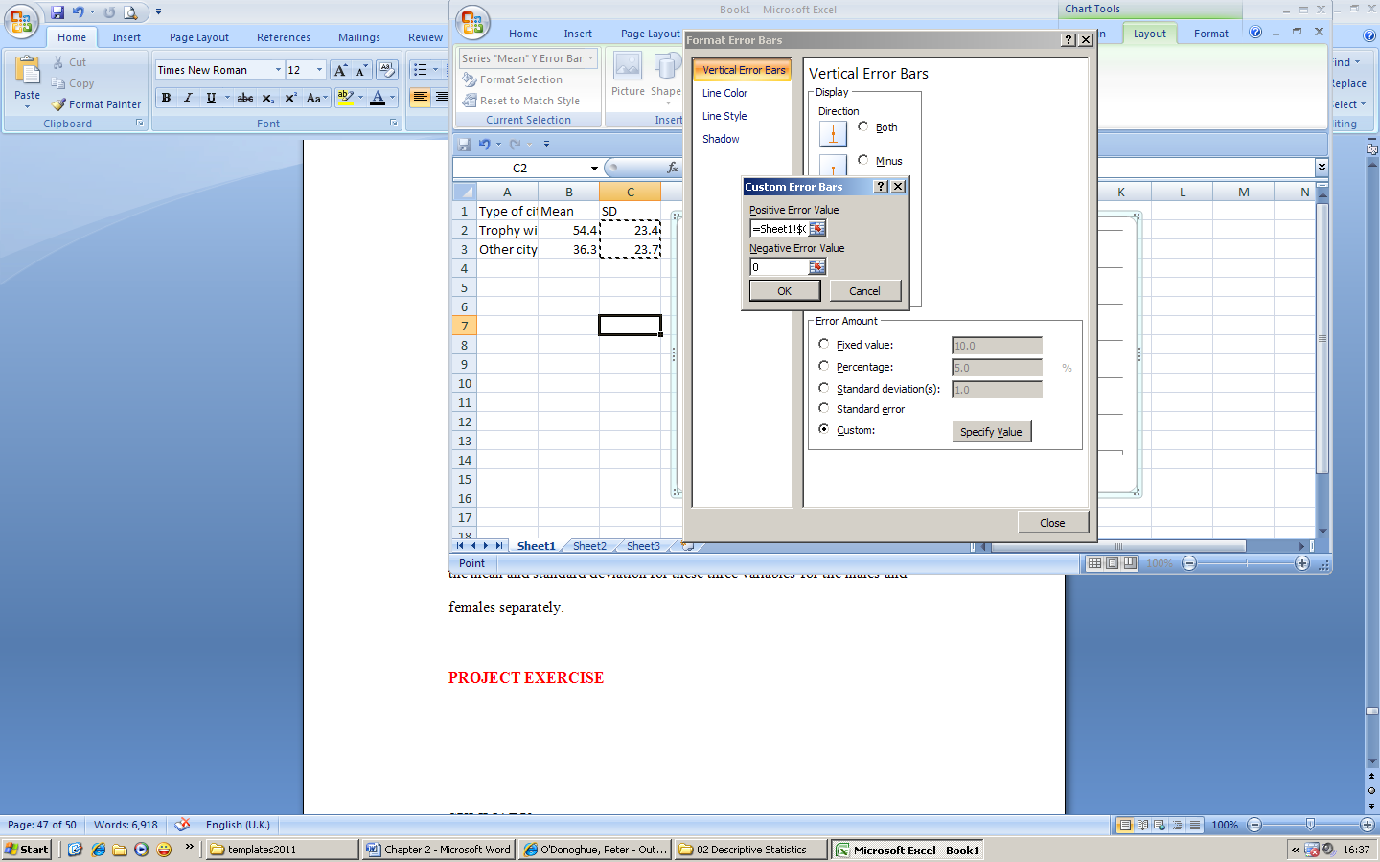

Figure 3.22. Custom Error Bars popup window.